Step Response and Advance Filter Topics
(Final Report – Experiment #6)

Vega, Roberto Javier SID: 003 110 717
Partner: Eddie Esquivel
EE 110L
LAB 6
Objectives:

- To investigate the step response of capacitive and inductive circuits
- To design and measured an advanced RC filter.

Theory:

- Circuits
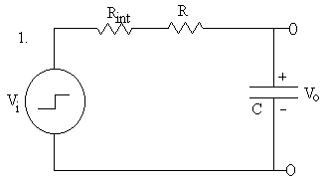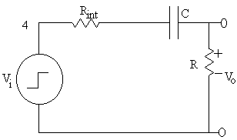
τ = RC

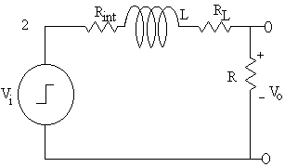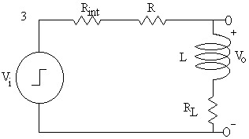
τ = L / R_{total}

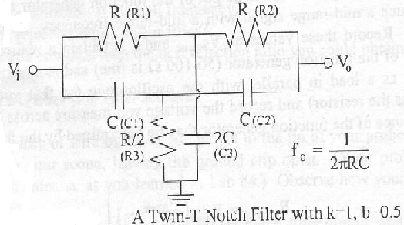

Procedure:

We started by measuring the internal resistance of the function generator when it produces square waves. To do this we started by applying a square wave of 10Vpp and 1 kHz to the circuit described in the lab manual, for this part V_{source} was measured. Then, a load resistor in the range of 50Ω to 100Ω was connected parallel with the function generator and V_{load} was measured.
For the next part of the experiment, we constructed the circuits described in the lab manual and we choose the values of R, L, and C, so that we selected a 10% of the reciprocal of τ calculated in the theory. We did this for each circuit in the theory part. Then, using a square wave, V_{o} was measured by the oscilloscope, which was adjusted to get one cycle on screen. Finally, τ was calculated and measured. We also draw the graphs described in the manual and we calculated the theoretical parts.
For the last part of this lab, we constructed the Twin-T Notch Filter, described in the theory part of this report. For the circuit we calculated the frequency that was blocked, first by theory and later by the measurements obtained in the laboratory.

Data Obtained Experimentally of each circuit:

Data Analysis and Plots:

After carefully followed the procedures described in the lab manual, all the data recorded for the experiments were displayed in the tables shown above. For each of the circuits that we built we calculated the resonance frequency and we colored the most likely real value to be according the theory of the experiment. For the first circuit of this lab the calculated value was around 12.65 KHz, and the actual value obtained was very close to this one, showing a minimum margin of error around 0.7% of the actual theoretical value. The voltages across the inductor, capacitor and resistor were changing with the change of values in the frequency, as it was supposed to happen.
For the second circuit built, the resonance frequencies were also very similar to the calculated with the theory. The values were around 1.5% of error, indicating that the experiment was following the theory. The values were around the 8.5KHz for the second circuit and the values of voltage, current and theta angle were also indicated in the tables. Again the graphs plotted helped to illustrate the change of voltage, current, gain and theta values with respect to the frequency and their dependency in the resonance frequency as well.
The voltages across the resistor, capacitor and inductor were in the experiment were expected from step#4 in prelab. First, the capacitor and inductor were charged by the voltage source. Then, when the capacitor released energy, the inductor would be charged by the capacitor and vice versa. As a result, the voltages across the inductor and capacitor were high.
In the second part, the mutual inductive property of inductor was examined. When the second inductor was moved away from the first inductor, the voltage across the second inductor dropped with the reciprocal of the distance between the two inductors. The values obtained showed us that the actual drop of voltage was cubically, in other words a value of n equal to 3.
Mutual inductance is a safer alternative for charging electric cars than plugging a power cord into the car because there is no direct contact between the car and the power supply. As a result, the power supply would not be damaged easily since the car can move away immediately in case of danger.

Conclusion:

In conclusion, the experiment was very successful. The resonant frequencies and phase differences of the elements in a RLC band pass filter were calculated and measured. The values obtained were ok with the values that the theory would indicate. The plots given in this lab report showed the changes and the dependency of each circuit in the frequency applied. We were able to understand the idea behind the resonance frequency and how it can be used in circuit design. Also, the theoretical part of this experiment was proven by the effect of the change in the impedance, at low, high and resonance frequencies. In the second part of the experiment, we were able to understande the mutual inductance property of inductors, which were separated by a small distance. As a result, the two main objectives of the experiment were accomplished.

